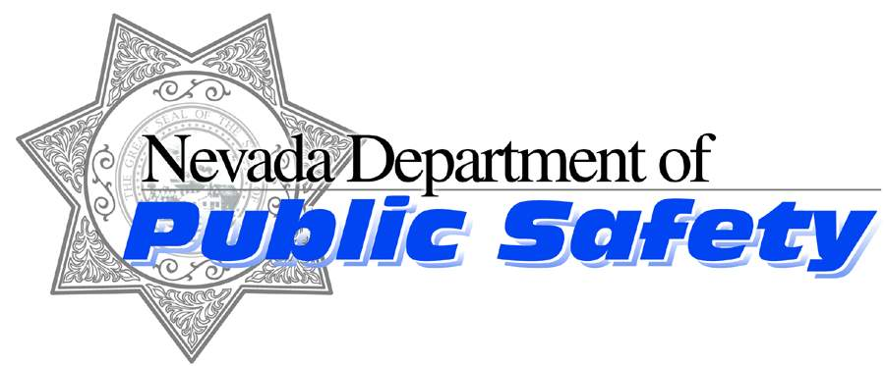
Parole and Probation Division

Brian Sandoval

Governor

James Wright

Director

Dennis Osborn
Chief
Nevada Highway Patrol
https://nhp.nv.gov
Like us on Facebook follow us on Twitter
October 23, 2015

Trooper Dave Gibson
Director’s Office
Public Information Officer
775-684-4572 or (775) 434-9128
dgibson@dps.state.nv.us

Media Release

The Nevada Department of Public Safety’s Parole and Probation Division Conducts 9th Annual Halloween Operation “Scarecrow” in conjunction with United States Marshals Service’s Operation “Trick Or Treat”

In an effort to provide enhanced safety for children who may be targeted by sexual predators during the Halloween holiday, and to verify compliance with both sex offender registration requirements and conditions of supervision, officers from the Nevada Department of Public Safety-Division of Parole and Probation, along with the US Marshals Service’s (USMS) Fugitive Task Force will simultaneously conduct Operations Scarecrow and Trick Or Treat during the week of October 26th to 31st, 2015.

The objectives of these operations is to ensure there is no contact between Division-supervised sex offenders and children on Halloween by giving specific direction in advance to supervised sex offenders and providing enhanced community supervision to high risk sex offenders and those with minor victims. Supervised sex offenders will not be permitted to participate in any activity which could potentially lure children to or near their residences, to include a restriction that they cannot have home parties or distribute candy to children on Halloween. Additionally, throughout the week preceding Halloween, Parole and Probation and USMS Task Force officers will be contacting Division-supervised sex offenders to verify their compliance with state law registration requirements, ensure they are not engaging in associated holiday activities that could attract children, and to verify compliance with their terms and conditions of supervision.

Throughout the month of October, Division officers have provided supervised sex offenders with written notices of “Offender Halloween Restrictions.” These offenders were instructed to avoid any contact with children during the Halloween holiday and to avoid participation in any Halloween-related festivities involving or potentially involving children. Officers will be conducting home visitations and surveillances to determine offender compliance and to detect any potential violations of the “Offender Halloween Restrictions” provided to them. Officers will make as many contacts as possible over the five day operation. Enforcement action regarding violations will be determined on a case-by-case basis.

WHAT: Operation Scarecrow and Operation Trick or Treat
WHERE: Reno, Sparks, Carson City and Washoe County
WHEN: October 26 through October 29 (Trick or Treat); October 31, 2015 (Scarecrow)
CONTACTS: Monday, 10/26: Lieutenant Jena Adrian, 233-8559 (jadrian@dps.state.nv.us);
Tues-Saturday: Sergeant Lisa Pierrott, 684-2359/232-7488 or lpierrott@dps.state.nv.us
XXXXX

