FOR IMMEDIATE RELEASE: December 29, 2016

CONTACT: Lieutenant Jack Peeler, 775-720-1629, jpeeler@dps.state.nv.us

Law Enforcement Strives for Zero Fatalities: Avoid Impaired Driving and Riding During the Holiday’s

Northern Nevada – Each year, the holiday brings an increase of alcohol consumption, resulting in the surge of injuries and fatalities on Nevada’s roadways. With impaired driving and riding a top traffic problem for Nevada, Nevada Highway Patrol is working in conjunction with agencies statewide aligned with Joining Forces to boost enforcement efforts from December 16, 2016 through January 3, 2017.

The National Highway Traffic Safety Administration (NHTSA) has found that drivers at a breath alcohol level of 0.08 percent, the legal limit in every state, were about four times more likely to crash than sober drivers. Drivers with an alcohol level of 0.15 percent were 12 times more likely to crash than sober drivers. Marijuana users were about 25 percent more likely to be involved in a crash than drivers with no evidence of marijuana use.

Nevada Highway Patrol is fully staffed and prepared to ensure that all those that choose to utilize Nevada’s Highways as a means of transportation into the New Year do so safely, and do not get behind the wheel if even the slightest bit impaired. Don’t risk it. Plan just as much about getting home as you do going out.

In efforts to achieve the “Zero Fatalities” goal, drivers and riders are encouraged to know the law for blood alcohol levels and to abide by the following guidelines:
- designate a sober driver before drinking;
- use a taxi, call a sober friend or family member or use public transportation if impaired;
- take advantage of local sober ride programs;
- call 911 if a drunk driver is spotted on the road;
- take the keys or assist in making other arrangements for someone who is about to drive or ride while impaired

For resources and laws pertaining to impaired driving and riding, please visit http://www.zerofatalitiesnv.com/dont-drive-impaired. Follow Zero Fatalities Nevada on Facebook, Twitter, YouTube and @ZeroFatalitiesNV on Instagram.

Trooper Duncan Dauber
Public Information Officer
Nevada Highway Patrol-Northern Command West
(775) 600-5568 or (775) 689-4680

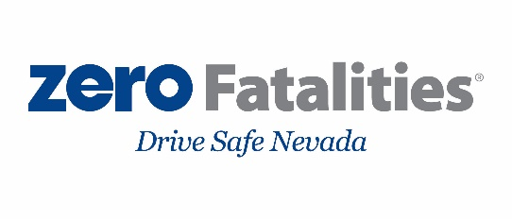
ddauber@dps.state.nv.us

