Media Contacts: Trooper Dan Gordon dgordon@dps.state.nv.us 775-434-9133
Agencies Name: Nevada Highway Patrol
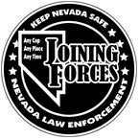
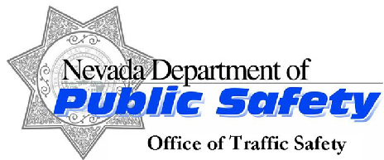

FOR IMMEDIATE RELEASE:

Don’t Find Yourself on the Wrong Side of The Law
If You’re Drinking, Find a Sober Ride or Law Enforcement Will Find One For You

May 1, 2017, Law enforcement officers statewide will be Joining Forces increasing patrols for impaired drivers and riders May 1st through May 7th, 2017. Making the decision to drive impaired can quickly turn a good time into a bad time with lasting consequences. If drinking is involved, be sure to plan ahead and designate a sober driver or find a sober ride from a friend or a taxi. Impaired driving not only puts your life and the lives of others in danger, the cost of driving under the influence is high. The average estimated cost of a DUI when legal fees, court fines and higher insurance rates are considered is over $10,000.

“If you drive impaired, you are endangering everyone….including yourself. Alcohol, Marijuana, prescription meds…..doesn’t matter! Even buzzed driving is drunk driving! Get a designated driver. Take the bus. Call a taxi or Uber. “

Law enforcement officers encourage motorists to call 911 if they witness drivers or riders that may be impaired.

For more information, please visit www.ZeroFatalitiesNV.com/sober.

###

