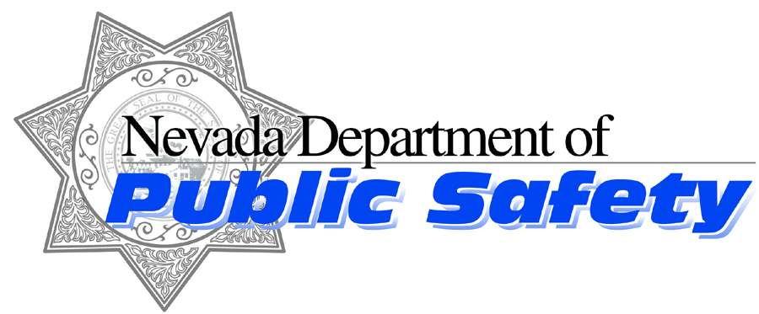

Brian Sandoval

Governor
John O’Rourke
Interim Chief
Nevada Highway Patrol

James Wright

Director

Nevada Highway Patrol
https://nhp.nv.gov
Like us on Facebook follow us on Twitter
October 8, 2017

Trooper Chelsea Stuenkel
Nevada Highway Patrol – Southern Command
Public Information Officer
cstuenkel@dps.state.nv.us or (702) 432-5277

Media Release
Road Rage Leads to Fatal Crash

On Sunday, October 8, 2017, at approximately 12:54 p.m., NHP troopers were dispatched to a multiple vehicle crash on Interstate 15.
Preliminary investigations show that a silver Jeep SUV was traveling in a reckless manner southbound on IR15, south of mile marker 93 (Clark County) in the left travel lane. A black BMW M5 sedan was also traveling southbound on IR15 in front of the silver Jeep. A red Mini Cooper coupe was traveling northbound on IR15 in the middle lane south of the Jeep and BMW. A silver Nissan Pathfinder SUV was traveling northbound on IR15, south of the Mini Cooper in the right lane.
According to witness statements, the black BMW, the silver Jeep, and a black Cadillac Escalade were engaging in reckless driving behavior due to road rage. At one point during the road rage incident the left rear passenger of the Cadillac threw a bottle at the silver Jeep.
The driver of the silver Jeep attempted to pass the black BMW by traveling in the left paved shoulder and dirt/rock median. The right side of the Jeep struck the left side of the BMW. The BMW was redirected southwest across the travel lanes and into the south dirt shoulder where it struck an embankment. The Jeep re-entered the left travel lane of southbound IR15. The driver steered the Jeep left and lost control causing the Jeep to rotate counterclockwise and travel across the dirt/rock median into the northbound IR15 travel lanes. The right side of the Jeep was struck by the front of the Mini Cooper. The front of the Nissan SUV struck the right front of the Mini Cooper.
The 69 year old male driver and sole occupant of the Mini Cooper succumbed to injuries sustained in the crash and was declared deceased on the scene. The driver was later identified as Henderson, NV resident, Michael Prinaris.
The 35 year old male driver of the Jeep was transported to UMC trauma with life threatening injuries. He is currently stable at UMC. He has been booked in absentia for felony reckless driving with death.
The 24 year old male driver of the BMW, Nan Ying sustained no injuries and was booked into the Clark County Detention Center for misdemeanor reckless driving.
The 19 year old male driver of the Cadillac, Jincheng Sun was also booked into the Clark County Detention Center for misdemeanor reckless driving.
The 20 year old male passenger of the Cadillac who threw the bottle at the Jeep was also booked into the Clark County Detention Center for littering.
The 73 year old male driver and the 73 year old female passenger of the Nissan SUV were transported to UMC trauma with non-incapacitating injuries.
Page 1 of 2

This is an active investigation and due to the fact that the driver of the Jeep remains at UMC his identity will not be released at this time.
This marks NHP-Southern Command’s 46th fatal crash resulting in 49 lives lost.
Please contact Trooper C. Stuenkel at 702-469-3882 or Trooper J. Buratczuk at 702-533-6808 with any questions.





