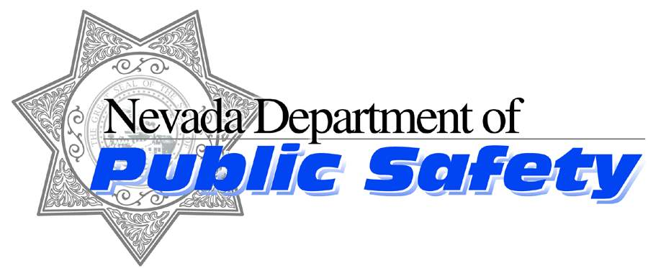

Brian Sandoval

Governor

James Wright

Director

Dennis Osborn
Chief
Nevada Highway Patrol
Nevada Highway Patrol
https://nhp.nv.gov
Like us on Facebook follow us on Twitter

January 19, 2014

Trooper Dave Gibson
Nevada Highway Patrol – Northern Command
Public Information Officer
dgibson@dps.state.nv.us (775) 434-9128

Media Release

Two Motorcycles Collide on Geiger Grade Killing One

On Monday, January 19, 2015 at approximately 4:15 p.m., Troopers from the Nevada Highway Patrol were dispatched to a motorcycle accident that occurred on State Route 341 (Geiger Grade) between mile posts two and three in Washoe County just south of Loftis Dr.
The crash investigation details indicate a 2003 black Harley Davidson motorcycle ridden by 35 year old Reno resident (who’s name is being withheld until next of kin has been notified) was traveling southbound on SR341 when for reason unknown crossed the center lane line and into the northbound lane where he collided with a 2014 black Harley Davidson motorcycle traveling north ridden by 35 year old Reno resident Jerald Allen Bailey. Each rider was thrown from their bikes. Mr. Perry was transported by Care Flight to Renown Regional Medical Center and was later pronounced dead. Mr. Bailey was also transported to Renown by ground ambulance for non-life threatening injuries.
One motorcycle came to rest in the northbound travel lane and the other on the eastside dirt shoulder. SR 341 was blocked while alternating traffic flow for approximately 3 hours as the NHP investigated and diagramed the accident scene. The roadway was completely opened to traffic just before 8:00 pm. It is unclear at this time as to the accident causing factors. The investigation is still ongoing. This area of SR341 has one lane in each direction and is a 45 mph speed zone and there is no roadway lighting.
Trooper Doug Hildebrand of the Nevada Highway Patrol’s Multi-Disciplinary Investigation and Reconstruction Team (MIRT) is investigating this incident. Anyone who may have witnessed this incident or who may have information related to this incident is encouraged to reach out to him at (775) 689-4623 or dhildebrand@dps.state.nv.us regarding case number NHP-150101437.

Page 1 of 2

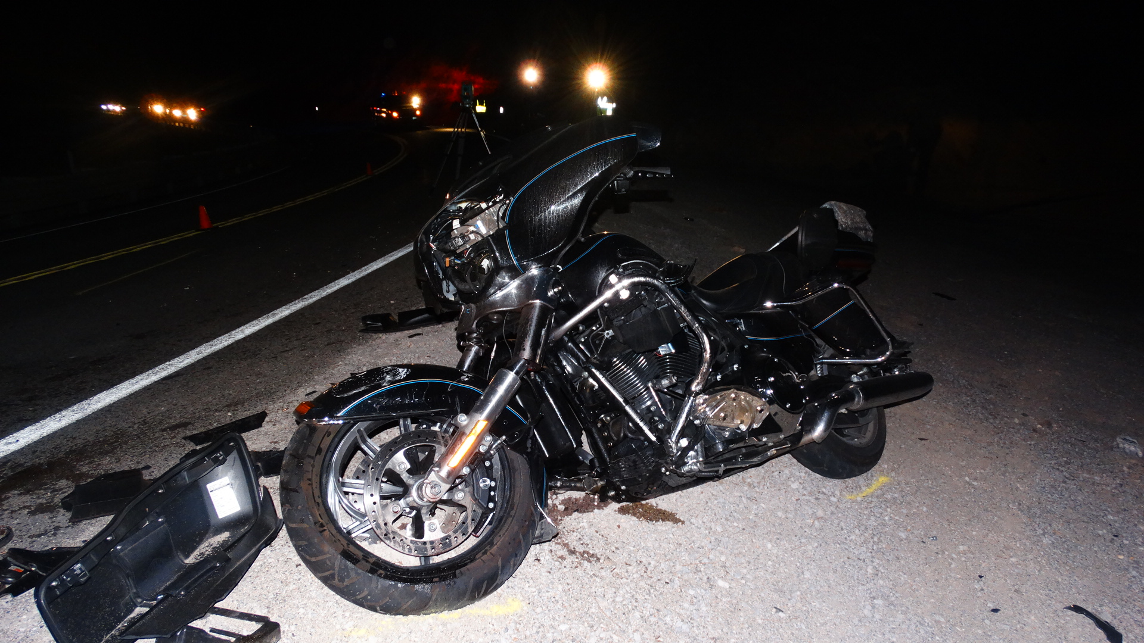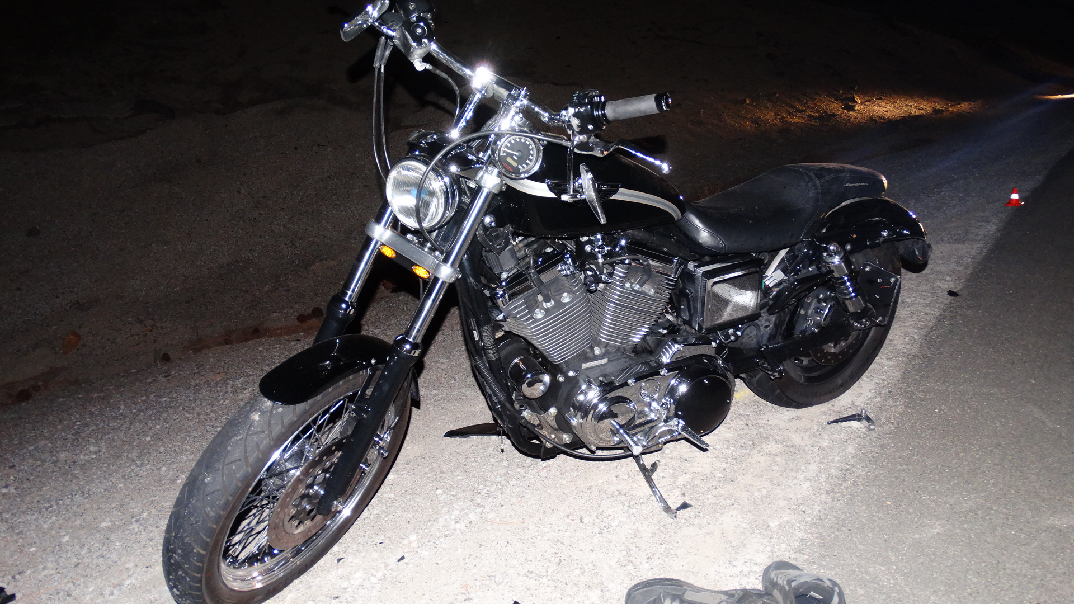

XXXX

